**Expert ID/Name: Nstructive**

**Date: 06-Nov-2020**

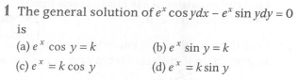

**Answer:**

|  |
| --- |
| MCQ Type Answers |
| Choices |
| Tips:  1.  2. |

|  |  |  |  |  |  |  |  |  |
| --- | --- | --- | --- | --- | --- | --- | --- | --- |
| Correct Answer: (a)  Given: Differential equation is  To find : General solution of differential equation is  Explanation:  Step 1:   |  |  | | --- | --- | | Instruction | Separate the terms dy and dx. | | Calculation |  |   Step 2:   |  |  | | --- | --- | | Instruction | Apply the integration on both sides,. | | Calculation | Now, put | |

|  |
| --- |
| Final answer:  i.e. The general solution of is |